SafetyInstructions inthe Highway Engineering laboratory

In general, all staff and students who undertake work in the laboratories must take reasonable care of their own health and safety and the health and safety of others

Highway Engineering laboratories carry out testing on asphalt and binders. The use of hot materials is always a potential for hazard. Often as civil engineering does not require handling of small amounts of materials bitumen safety is handled by teaching operational procedures and needs, these are often either inappropriate or cumbersome in a laboratory.
Highway lab safety rules  1. Be sure to read all fire alarm and safety signs and follow the instructions in the event of an accident or emergency.  2.Make sure you are aware of where your lab's exits and fire alarms are located.  3. Do not chew gum, drink, or eat while working in the lab.  4. Laboratory glassware should never be utilized as food or beverage containers.  5. Never use lab equipment that you are not approved or trained by your supervisor to operate.  6. If an instrument or piece of equipment fails during use, or isn't operating properly, report the issue to a technician right away. Never try to repair an equipment problem on your own.  7. If you are the last person to leave the lab, make sure to lock all the doors and turn off all ignition sources.  8. Report all injuries, accidents, and broken equipment or glass right away, even if the incident seems small or unimportant.  9. If you have been injured, yell out immediately and as loud as you can to ensure you get help. | 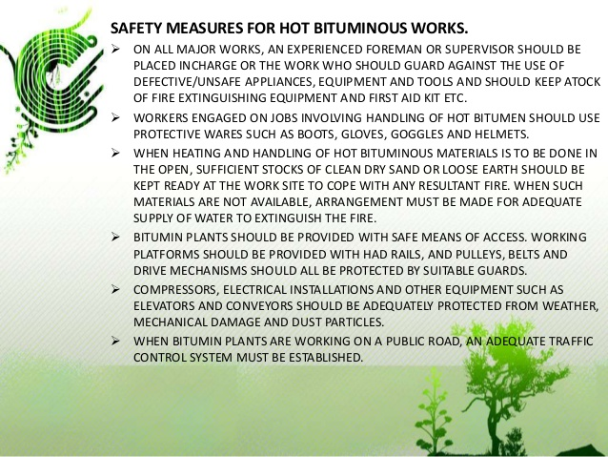

Working Alone  ‘Working Alone’ means performance of any work by any individual who is  out of audio or visual range of another person for more than a few  minutes at a time.  The following guidelines are to be followed:  • Any non routine job function with identifiable safety hazards in  which the probability of an accident occurring is sufficient to warrant  the presence of more than one person.  • It is recognised that even the simplest of tasks contain certain  hazards and hence working without a second person is to be  avoided.  Laboratory Security  For reasons of both safety and security, use of the laboratory outside  normal working hours in the absence of technical staff is subject to  prior approval from the Head of Department and such permission, when  granted will apply only to the applicant, who will be expected to justify the need for such use, the duration and the lab areas/equipment which are intended to be used. | 